SANSKAAR PATNI
180905134 CSE-C 23

PART 1

3.1)HTTP
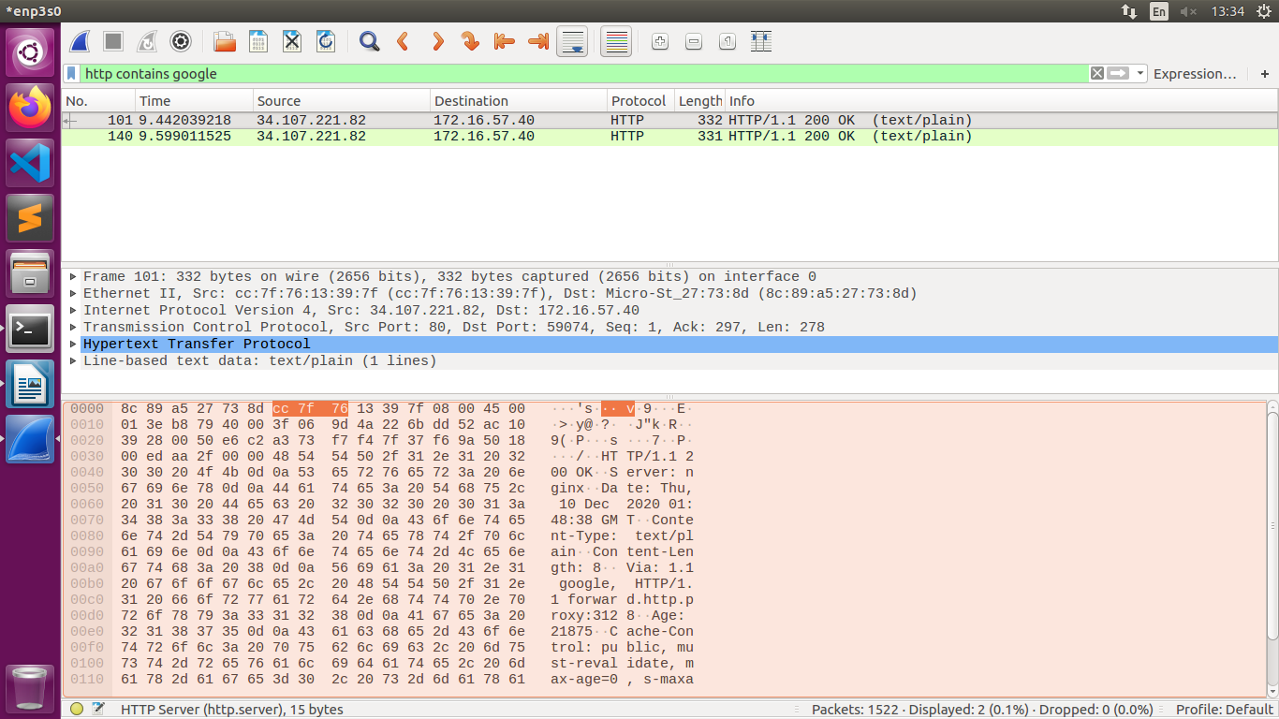
3.2 FTP
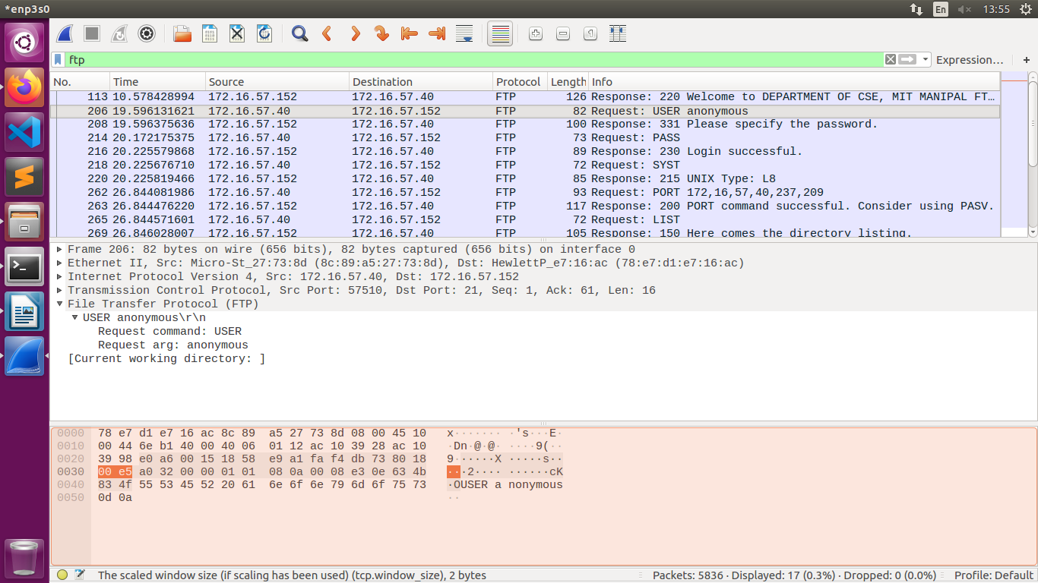

3.3 DNS
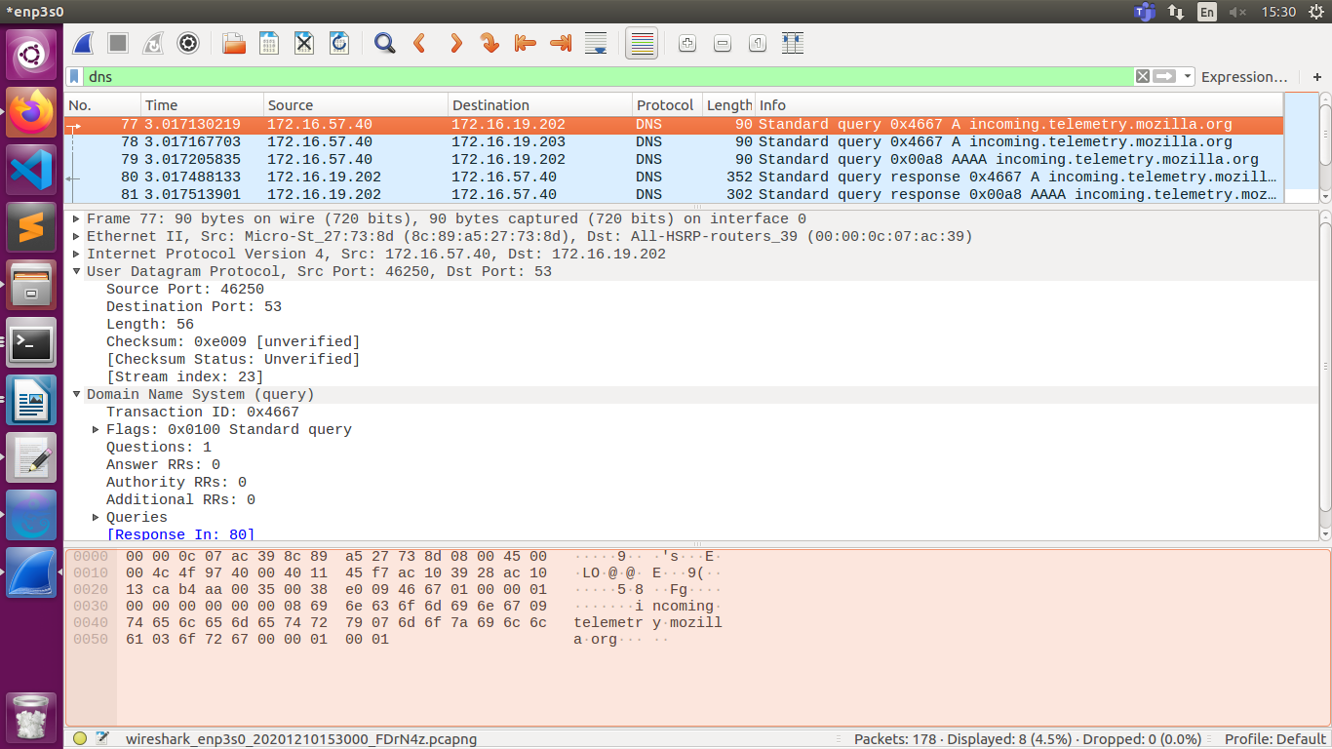

PART 2
4.1 4 VPCS AND SWITCH
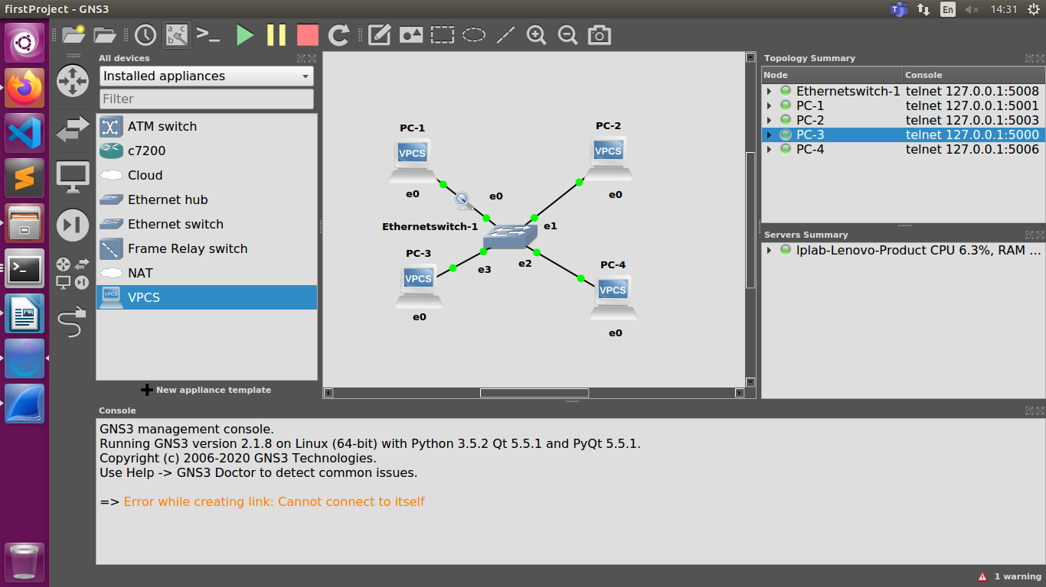

a)ARP cache with show arp
c)Ping pc2 from pc1
d)ARP cache
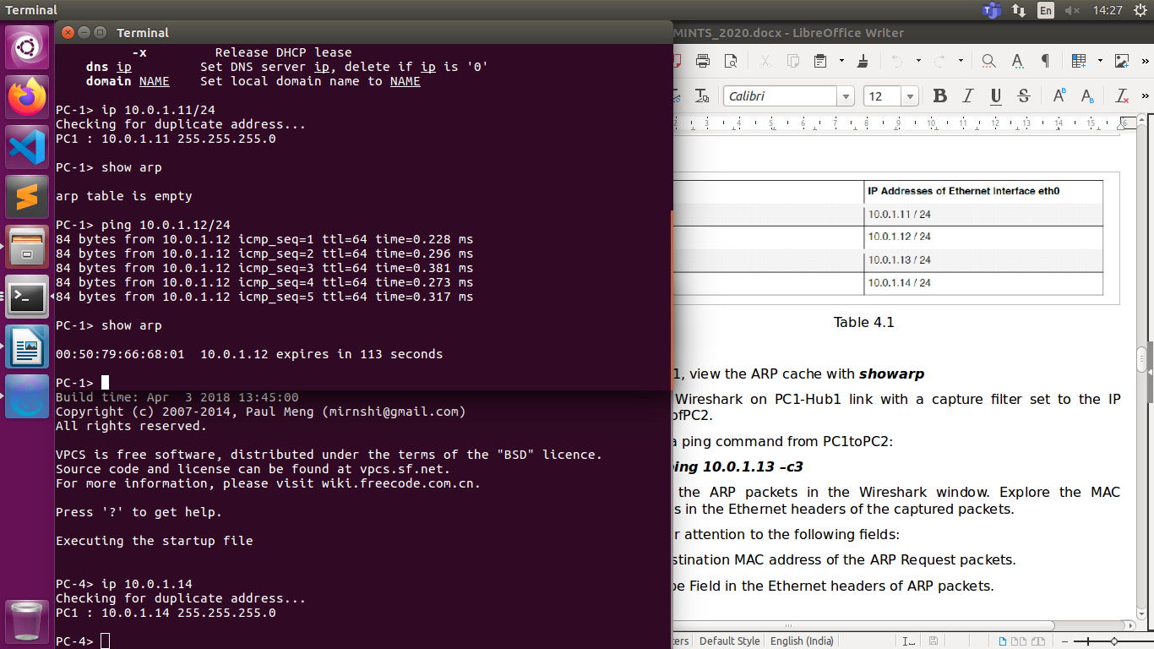
b)Wireshark capture of pc1 and switch, filter pc2
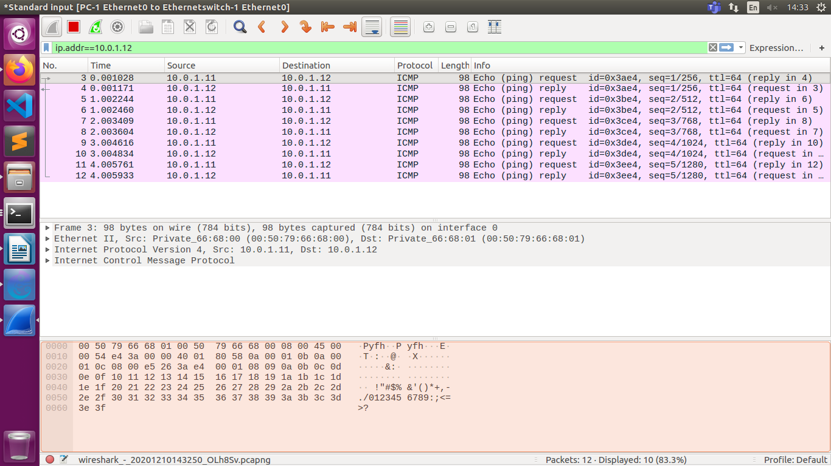
ARP packets Wireshark
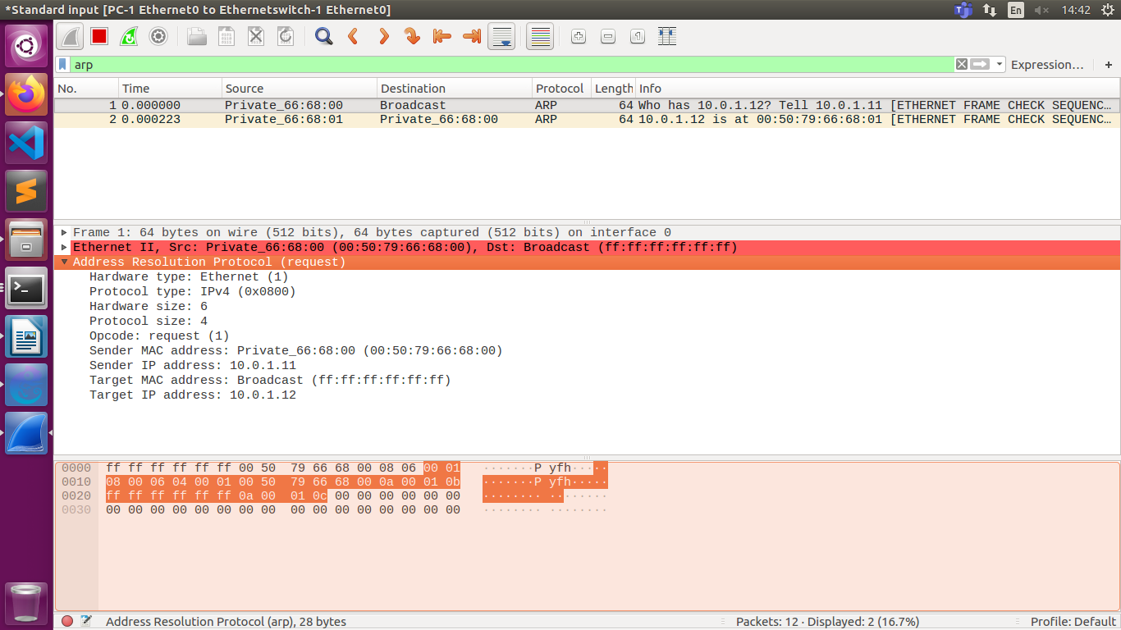

4.2
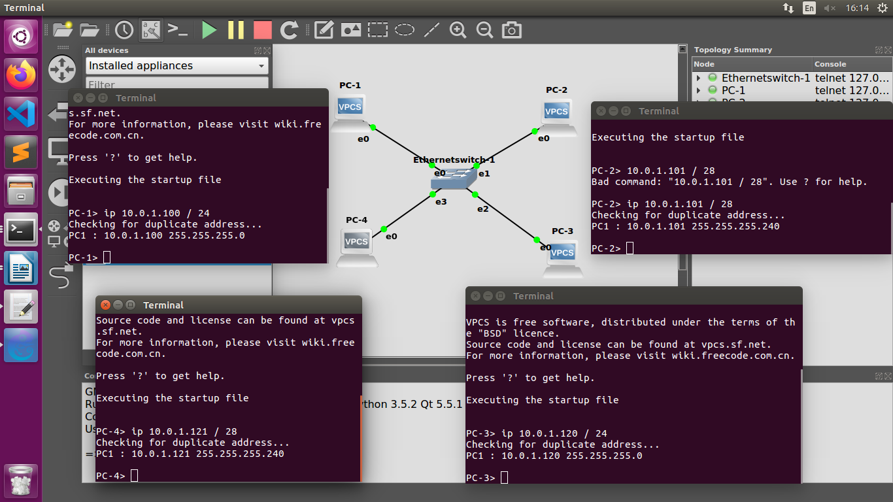

i. FROM PC1 ping PC3

84 bytes from 10.0.1.120 icmp_seq=1 ttl=64 time=0.250 ms
84 bytes from 10.0.1.120 icmp_seq=2 ttl=64 time=0.338 ms
84 bytes from 10.0.1.120 icmp_seq=3 ttl=64 time=0.319 ms
84 bytes from 10.0.1.120 icmp_seq=4 ttl=64 time=0.298 ms
84 bytes from 10.0.1.120 icmp_seq=5 ttl=64 time=0.294 ms

ii. From PC1 pingPC2.
84 bytes from 10.0.1.101 icmp_seq=1 ttl=64 time=0.217 ms
84 bytes from 10.0.1.101 icmp_seq=2 ttl=64 time=0.303 ms
84 bytes from 10.0.1.101 icmp_seq=3 ttl=64 time=0.311 ms
84 bytes from 10.0.1.101 icmp_seq=4 ttl=64 time=0.269 ms
84 bytes from 10.0.1.101 icmp_seq=5 ttl=64 time=0.269 ms

iii. From PC1 pingPC4.
10.0.1.121 icmp_seq=1 timeout
10.0.1.121 icmp_seq=2 timeout
10.0.1.121 icmp_seq=3 timeout
10.0.1.121 icmp_seq=4 timeout
10.0.1.121 icmp_seq=5 timeout
iv. From PC4 pingPC1.
No gateway found
v. From PC2 ping PC4.
No gateway found
vi. From PC2 ping PC3.
No gateway found
Wireshark op
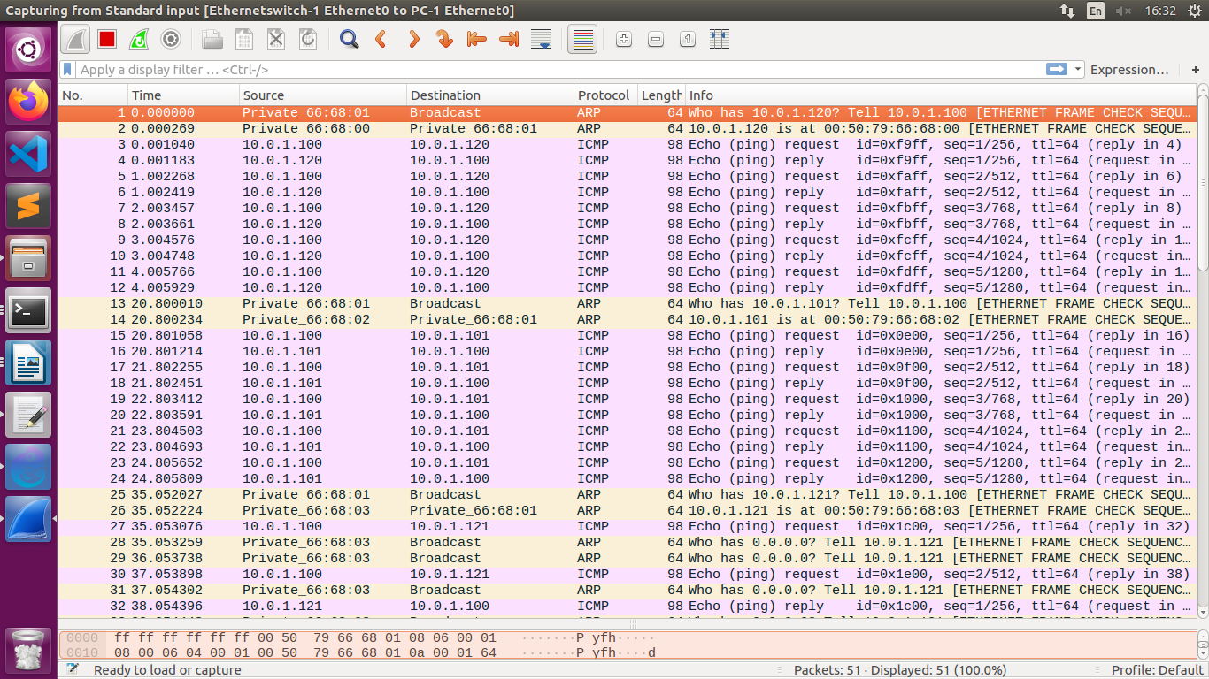

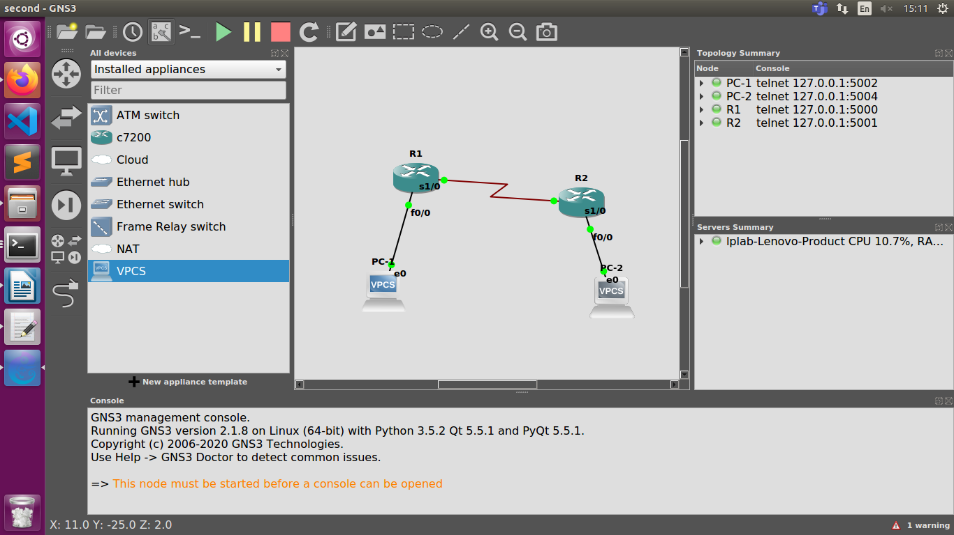
4.6)a)

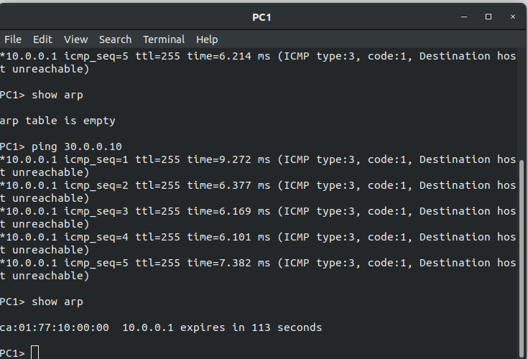

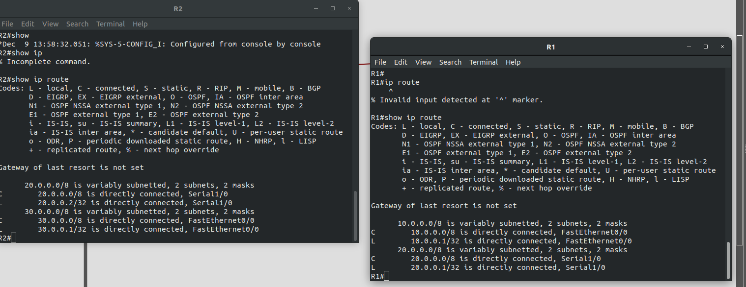
4.6)b
